Lecture No.3 PARASITOLOGY DR.Raad H.H.
Phylum Nemathelmiths
Class Nematoda
Characters of the class:
- Spp. of the class mostly are parasitic & few are free living worms .
- Nematode are unsegmented ; typically elongate cylindrical bodies .
- They have complete digestive tract & body cavity (Pseudocoel ) ; with single excretory mid ventral pore
- Diecious ( Bisexual separated sex Female & male ).
- They range in size from few to many centimeters in length .
- Males with bended ends usually & in Hook worms having Bursa .
- Females are larger than males .
- No respiratory or circulatory systems .
- They have nervous & excretory systems .
- They have mostly direct life cycle & also indirect life cycle
- the larval stages ( L 1 - L 2 - L 3 ) lives outside host in the environment called “ Geohelminths” ; while the larvae living inside host called “ Biohelminths “ ; usually the L 3 is the “ infective stage “ .
- Sense organs are important in classification of Nematoda :
- Amphids : which are minute pair lateral bodies at the anterior end of the worm .
- Phasmids : which are minute pair organs at the posterior end (post anal) of the worm .
- Forms of Esophagus ( are important in classification of Nematoda) :
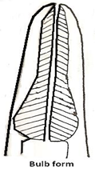
- Simple club → Ascaris ( adult stage )

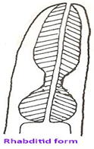
- Rhabditi form → e.g. L 1 - L 2 larval stages

Of nematode ; Strongyloides

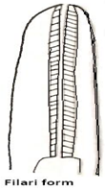
- Filari form → e.g. L 3 ( infective stage

Of Parasitic nematode)

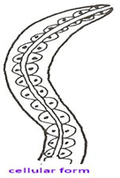
- Cellular form → e.g. Trichuris worm .

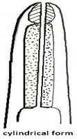
- Cylindrical →e.g. Spiruroida worms .

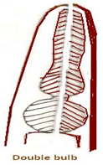
- Double clubbed → e.g. Ascaridia worms .

Ascaridia galli

- Types of Nematoda females :
- Oviparous →Ascaris .
- Ovilarviparous → lung worms (Dictyocalus ).
- Larviparous →either L₁ mature in Trichenllidae or immature (called Microfilaria ) in Filaria .
- Development of Nematoda in general :
Eggs → L 1 →L 2 ---→ L 3 ---→ L 4 ---→ L 5(immature worm)→ adult
{environment or inside intermediate host } { inside final host }
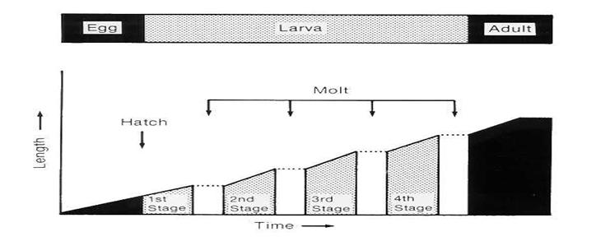

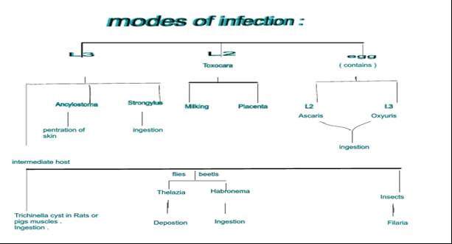

- Veterinary Nematoda classified to 5 orders :

Order |  | Family | Genus
 | Ascaridia | Ascaridae | Ascaris ; Toxocara; Toxascaris
 |  | Heterakidae | Ascaridia Heterakis
 |  | Oxyuridae | Oxyuris ;Enterobius;Passalurus
 | Srongylida  (Bursate Nematoda) | Strongylidae | Strongylus ;Trichonema ; Triodontophorus ; Chabertia; Oesophagostumum;  Mammomonogamus (Syngamus)
 |  | Ancylostomidae | Ancylostoma ;Uncenaria ;  Necator
 |  | Trichostrongylidae | Trichostrongylus ;Haemonchus; Ostertagia ;Cooperia ; Nematodirus ;
 |  | Dictyocaulidae | Dictyocalus; Protostrongylus
 |  | Metasrongylidae | Metasrongylus
 | Enoplida | Trichinellidae | Trichinella
 |  | Trichuridae | Trichuris
 |  | Capillaridae | Capillaria
 |  | Dictyophymidae | Dictyophyma
 | Rhabditida |  | Strongyloides
 | Spiruroida | Spiruroidae | Habronema ;Spirocerca
 |  | Thelazidae | Thelazia
 |  | Acuariidae (birds)
 |  | Tetramiridae (birds)
 |  | Drancuculoidae | Drancuculus
 |  | Ganthostomidae | Gnathostoma
 |  | Filariidae | Loa ; Burgia ;Wucheraria ;Parafilaria ;Dirofilaria ;
 |  | Onchocercidae | Onchocerca
 |  | Setariidae | Setaria ; Diptalonema

- Nematoda classified according to Skarjabin system (1944 – 1963 ) to “ 2 sub classes “ :
- Subclass Phasmida ; contains e.g. families of :
Ascaridae
Oxyuridae
Ancylostomidae
Trichostrongylidae
Strongylidae
Spiruroidae
Drancuculoidae
Ganthostomidae
Filariidae

B. Subclass Aphasmida : contains e.g. families of :

Trichinellidae
Trichuridae
Capillaridae
Dictyophymidae

Nematode systems :
- Body wall :
- The cellular hypodermis bulges into the body cavity or pseudocoelom to form four longitudinal cords a dorsal, a ventral, and two lateral cords which may be seen on the surface as lateral lines. Nuclei of the hypodermis are located in the region of the cords.
- The somatic musculature lying beneath the hypodermis is a single layer of smooth muscle cells. When viewed in cross-section, this layer can be seen to be separated into four zones by the hypodermal cords. The musculature is innervated by extensions of muscle cells to nerve trunks running anteriorly and posteriorly from ganglion cells that ring the midportion of the esophagus.
The space between the muscle layer and viscera is the pseudocoelom, which lacks a mesothelium lining. This cavity contains fluid and two to six fixed cells (celomocytes) which are usually associated with the longitudinal cords. The function of these cells is unknown.
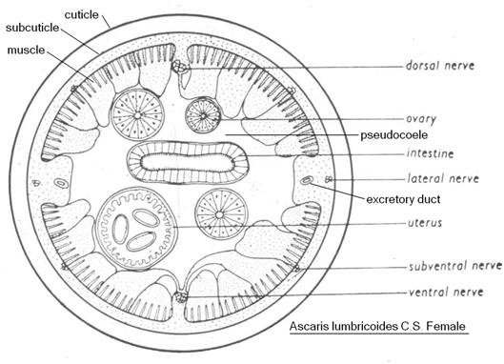

- The alimentary canal of roundworms is complete, with both mouth and anus. The mouth is surrounded by lips bearing sensory papillae (bristles). The esophagus, a conspicuous feature of nematodes, is a muscular structure that pumps food into the intestine; it differs in shape in different species.
Mouth contains either teeth or cutting plates or expanded buccal cavity.
The intestine is a tubular structure composed of a single layer of columnar cells possessing prominent microvilli on their luminal surface.
- The excretory system of some nematodes consists of an excretory gland and a pore located ventrally in the mid-esophageal region. In other nematodes this structure is drawn into extensions that give rise to the more complex tubular excretory system, which is usually H-shaped, with two anterior limbs and two posterior limbs located in the lateral cords. The gland cells and tubes are thought to serve as absorptive bodies, collecting wastes from the pseudocoelom, and to function in osmo -regulation.

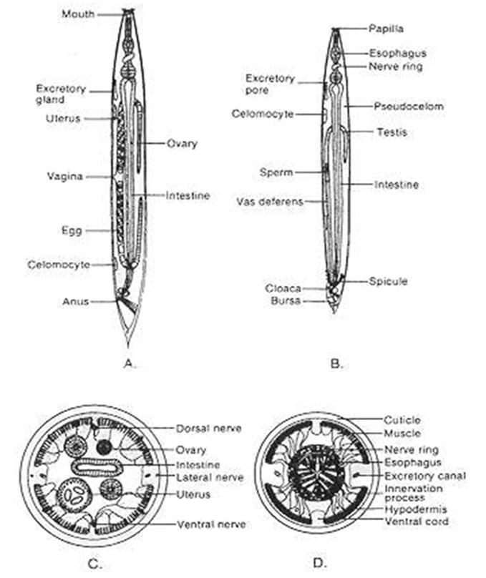

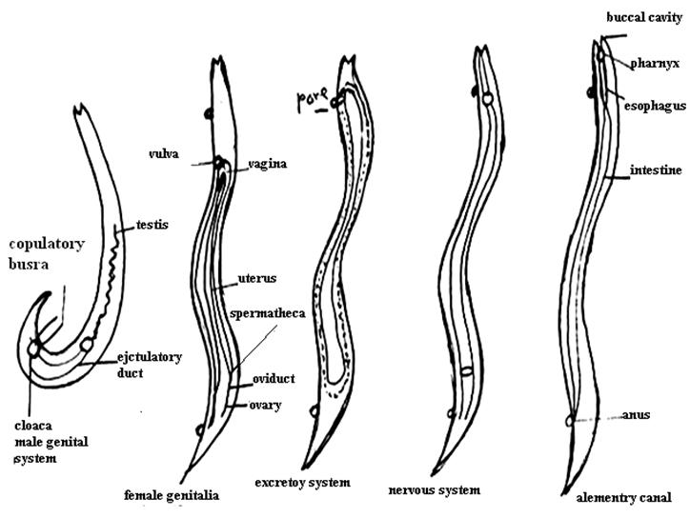

- Nematodes are usually bisexual. Males are usually smaller than females, have a curved posterior end, and possess (in some species) copulatory structures, such as spicules (usually two), a bursa, or both. The males have one or (in a few cases) two testes, which lie at the free end of a convoluted or recurved tube leading into a seminal vesicle and eventually into the cloaca. The female system is tubular also, and usually is made up of reflexed ovaries. Each ovary is continuous, with an oviduct and tubular uterus. The uteri join to form the vagina, which in turn opens to the exterior through the vulva. Copulation between a female and a male nematode is necessary for fertilization except in the genus Strongyloides, in which parthenogenetic development occurs (i.e., the development of an unfertilized egg into a new individual). Some evidence indicates that sex attractants (pheromones) play a role in heterosexual mating. During copulation, sperm is transferred into the vulva of the female. The sperm enters the ovum and a fertilization membrane is secreted by the zygote. This membrane gradually thickens to form the chitinous shell. A second membrane, below the shell, makes the egg impervious to essentially all substances except carbon dioxide and oxygen. In some species, a third proteinaceous membrane is secreted as the egg passes down the uterus by the uterine wall and is deposited outside the shell.
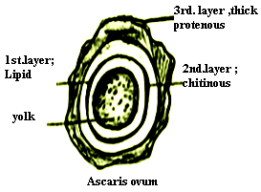

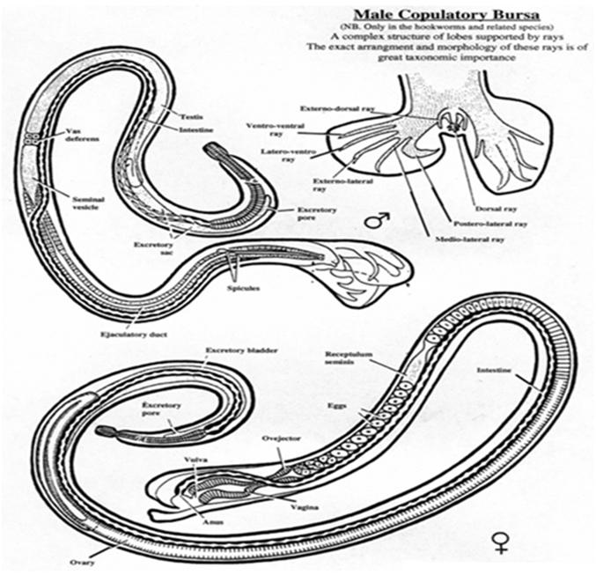
Most nematodes that are parasitic in humans lay eggs that, when voided, contain either an uncleaved zygote, a group of blastomeres, or a completely formed larva. Some nematodes, such as the filariae and Trichinella spiralis, produce larvae that are deposited in host tissues.
- The developmental process in nematodes involves egg, larval, and adult stages. Each of four larval stages is followed by a molt in which the cuticle is shed. The larvae are called second-stage larvae after the first molt, and so on . The nematode formed at the fifth stage is the adult.
Figure . summarizes the adults location of several intestinal nematodes.

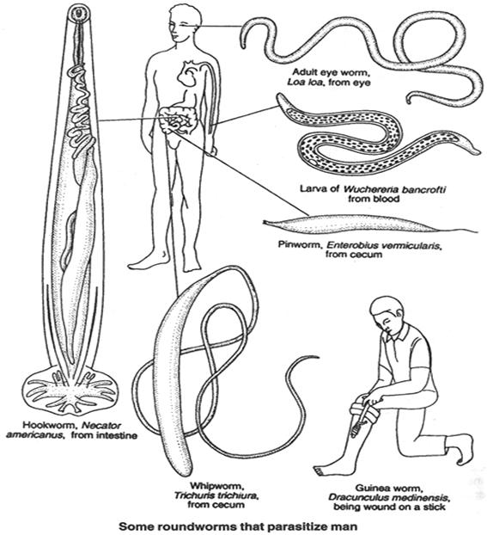

Fig. summarizes the eggs , 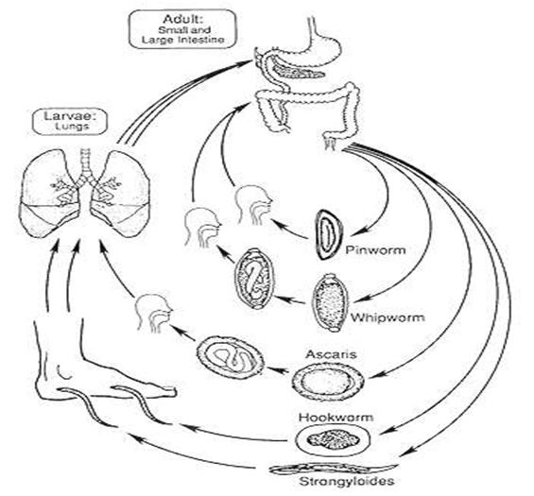 larva life cycles of several intestinal nematodes .

